

SKYE INSTRUMENTS LTD.
21, DDOLE ENTERPRISE PARK,
LLANDRINDOD WELLS,
POWYS. LD1 6DF. U.K.

TEL: +44 (0) 1597 824811
email: skyemail@skyeinstruments.com
website: www.skyeinstruments.com

CALIBRATION CERTIFICATE No : TQUA/006/0815

UNIT TYPE :- | TAG-PARQ
 | ……………………………………………….
OUTPUT :- | 0.01384 µA / µmol m⁻² s⁻¹
 | ……………………………………………….
DATE OF CALIBRATION :- | 30/07/2015
 | ……………………………………………….
LAMP REFERENCE :- | SK4
 | ……………………………………………….
A/D UNIT :- | F3352
 | ……………………………………………….
Calibrated against a National Physical Laboratory UK reference standard lamp.
Uncertainty 5% (typically < ± 3%) based on an estimated confidence of not less than 95%
Calibrated By :- | G. Sims
 | ……………………………………………….
Checked By :-
 | ……………………………………………….
Issue Date :- | 03/08/2015
 | ……………………………………………….
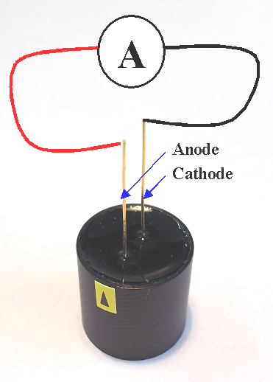
+ -

THIS UNIT IS DUE FOR RECALIBRATION WITHIN 2 YEARS OF THE ABOVE CALIBRATION DATE

